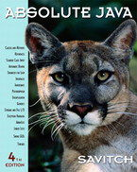

Name: ______________________ Seat # ____
Homework 2 – On Lecture 2 – Classes I
(100 points) Hours:

The homework is to be turned in as a PAPER AND PENCIL i.e., HANDWRITTEN ANSWER ONLY!(with your terminal #!) in the first ten minutes of the due date class.

Also an implementation in NetBeans Java is ALSO required, thus you are to submit the ZIPPED project to BB and download it in 232 PGH the first 10 minutes of class. Hardcopy with screenshots of the running program and the SOURCE CODE are also needed.
TURNING IN THE HOMEWORK INSTRUCTIONS will be PENALTY OF -10 points.
I UNDERSTAND THAT TURNING ANOTHER’s WORK IN is CHEATING.
I UNDERSTAND THAT ANY KIND OF DISSEMINATION of this WORK is CHEATING.

I CERTIFY THAT THE HOMEWORKs SOLUTIONs ARE MY OWN WORK!
V
X
?
SIGNATURE:

HOMEWORK CHECKLIST (YOU MUST GRADE YOURSELF!):

- DID TURN IN HOMEWORK INSTRUCTIONS? * -10 points
TA check, is Homework2.doc & Homework2.zip
in BB?

- 1.? 15 points
- 2.? 10 points
- 3.? 5 points
- 4.? 10 points

- 5.? WORD E + H .zip 40 points
- 6.? WORD E + H .zip 20 points
- Homework2.5JAVA.zip NOT submitted to BB? * -30 points
- Homework2.5JAVA.zip NOT running in class? * -30 points
- Homework2.6JAVA.zip NOT submitted to BB? * -10 points

- Homework2.6JAVA.zip NOT running in class? * -10 points

- If NOT, do not enter anything in the box!
TA grade or check

PLEASE ENTER YOUR GRADE IN THIS BOX:
By Hand?

I understand that if the .zip files are NOT in BB and I did not check the BOXES, I will get a ZERO for the Homework!
Screenshot?
Any DIAGRAM that is NOT the result of CUT and PASTE
WILL BE IGNORED (YOU WILL GET ZERO POINTS)

1. (15 pts) (BY HAND):

a. (2 pts) A program or software that uses and manipulates the objects of a class is called a _____ of that class.
A: instance
B: mutator
C: accessor
D: client

ANSWER:

b. (2 pts) Which of the following is a member access specifier?
A: private
B: protected
C: public
D: All of the above

ANSWER:

c. (2 pts) If a class object is declared in a user program, then the object can access ____ of the class.
A: only the private members
B: only the public members
C: both the private and public members
D: None of the above

ANSWER:

d. (2 pts) If a member function is used only to implement other member functions of a class and the user does not need to access the function, you should declare it ____. (p.653)
A: const
B: static
C: private
D: public
ANSWER:

e. (2 pts) Which is the syntax to invoke the default constructor?
A: className(classObjectName);
B: className classObjectName;
C: className classObjectName();
D: className() classObjectName;
ANSWER:

f. (2 pts) When a class object is declared, memory is allocated for ____ of each class object.
A: only the member variables
B: only the member functions
C: the member variables and the member functions
D: the member variables and function parameters

ANSWER:

g (3 pts) When a class is defined, ____.
A: memory is allocated for all public members
B: memory is allocated for all member variables and functions
C: no memory is allocated
D: memory is allocated for member variables only

ANSWER:

2. (10 pts) Identify the following Models: (BY HAND):

- (2 pts)

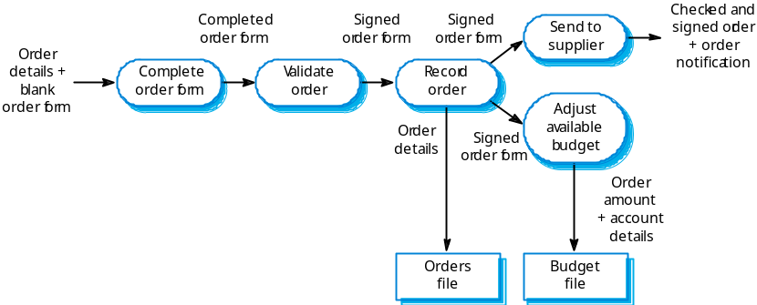

Answer:

- (2 pts)

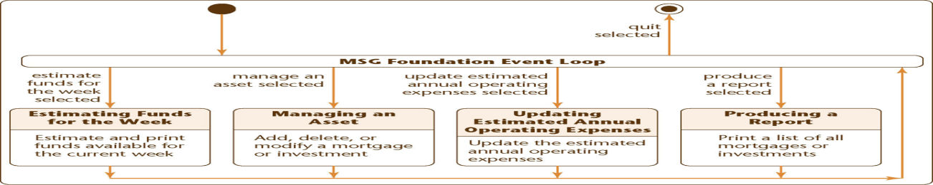

Answer:

- (2 pts)

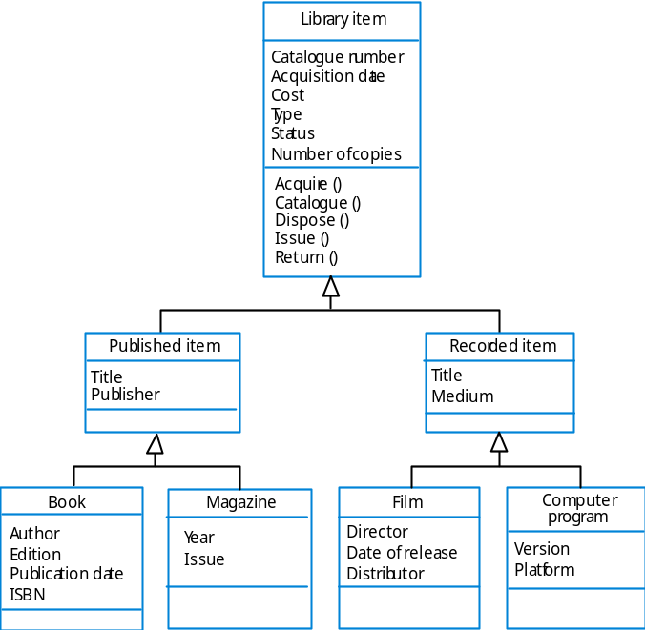

Answer:

- (2 pts)

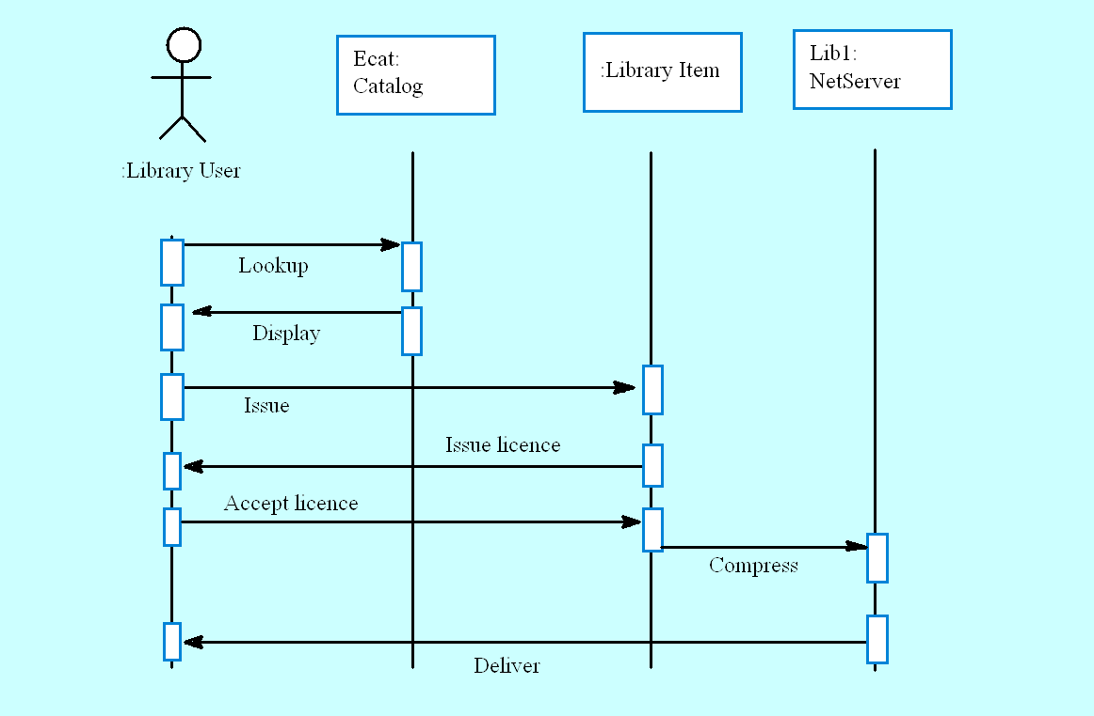

Answer:

- (2 pts)

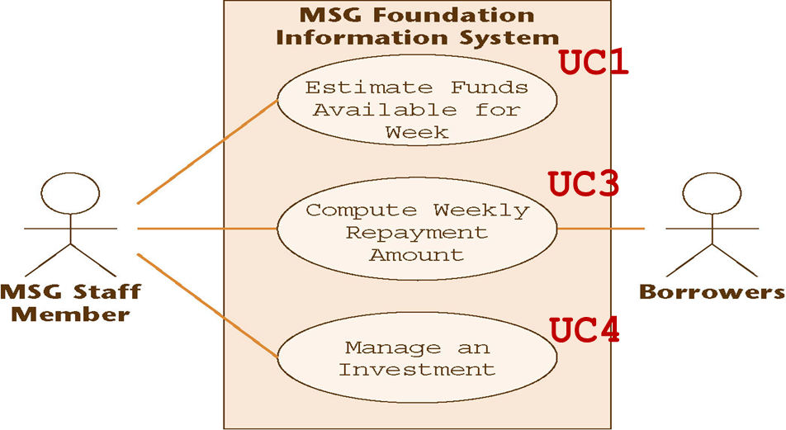

Answer:

3. (5 pts) (BY HAND):

Write a method happyGreeting that could be added to the Class DateFirstTry in Display 4.2 (A Class with More Methods). The method happyGreeting writes the string “Happy Days!” to the screen a number of times equal to the value of the instance variable day. For example, if the value of day is 3, then it should write the following to the screen:

Happy Days!
Happy Days!
Happy Days!

Use a local variable.

Answer:

4. (10 pts) (BY HAND):

Suppose you have defined a class like the following for use in a program:

public class YourClass
{
private int information;
private char moreInformation;

public YourClass( int newInfo, char moreNewInfo)
{
< Details not shown.>
}

public YourClass()
{
< Details not shown.>
}

public void doStuff()
{
< Details not shown.>
}
}

Which of the following are legal in a program that uses this class?

YourClass anObject = new YourClass( 42, ' A');
YourClass anotherObject = new YourClass( 41.99, ' A');
YourClass yetAnotherObject = new YourClass();
yetAnotherObject. doStuff();
YourClass oneMoreObject;

Answer:

5. (40 pts) UML Class Diagram (MICROSOFT WORD; Textual Analysis – TA then Copy&Paste&Rearrange to create the UML CLASS Diagram).

Define a Class whose objects are pets. The Class
should have instance variables for the name, age, and weight.

Include default Constructor, Constructor with 3 parameters, mutator

methods, and accessor methods. Include a toString method and an equals method.
In addition please add a HOMEWORK2.5 Class that contains only main method.

a. (10 pts) Draw the UML Class Diagram (MICROSOFT WORD):

ANSWER:
Any DIAGRAM that is NOT the result of CUT and PASTE
WILL BE IGNORED (YOU WILL GET ZERO POINTS)

b. (20 pts) Create in Netbeans 6.9.1 HOMEWORK2.5 Project build and run - prompting for the name SPLAT the age 13 and the weight 15 (use Scanner JAVA Class);

The output should display “Name: SPLAT Age: 13 years Weight: 15 pounds”. Insert as the answer a Project screenshot (3 windows, please see the template at the end of this document).

Please make sure you submit the HOMEWORK2.5 ZIPPED NetBeans 6.9.1 project to Black Board!

In this figure this is the FOLDER with the PROJECT run in Lecture2!
This is the ONE THAT YOU NEED TO ZIP and submit to BB!
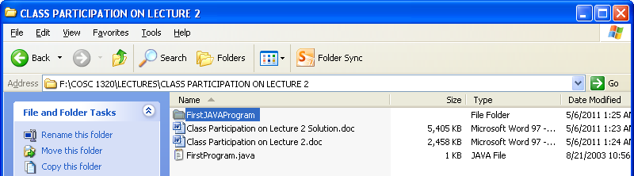

DO NOT RAR!
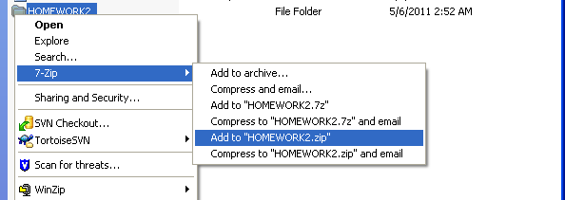ANSWER:
c. (10 pts) Answer the following based on b. (BY HAND):

c1. Which are the instance variables?
ANSWER:

c2. Which are the Constructors?
ANSWER:

c3. Which are the Accessor methods?
ANSWER:

c4. Which are the Mutator methods?
ANSWER:

c5. Which are the Class instance variables?
ANSWER:
6. (20 pts) UML Class Diagram (MICROSOFT WORD; Textual Analysis – TA Cut&Paste&Rearrange).

Define a Class whose objects are records on animal species. The Class should have instance variables for the species name, population, and growth rate. The growth rate is a percentage that can be positive or negative and can exceed 100 percent.
Include a boolean valued method named endangered that returns true when the growth rate is negative and returns false otherwise.

Include default Constructor, Constructor with 3 parameters, mutator

methods, and accessor methods. Include a toString method and an equals method.
In addition please add a HOMEWORK2.6 Class that contains only main method.

a. (10 pts) Draw the UML Class Diagram (MICROSOFT WORD):

ANSWER:
Any DIAGRAM that is NOT the result of CUT and PASTE
WILL BE IGNORED (YOU WILL GET ZERO POINTS)

b. (10 pts) Create in Netbeans 6.9.1 HOMEWORK2.6 Project build and run - that tests each method of this Class. Insert a “legal” Project Screenshot (Source Window, Output, and the 4 lines of comments, please see the template at the end of this document).

Please make sure you submit the HOMEWORK2.6 ZIPPED NetBeans 6.9.1 project to Black Board!

ANSWER:
UML Class Diagram Symbols:

Catalog 1: name:String
Catalog

Catalog 1: addArtist(String artist) void;

Step 1: Sample Screenshot (whole screen PRINT key on the keyboard will copy the screen with the following information:

Project, Output Window, Significant Source Code

Step 2: Open a word document and paste copy of the screen!

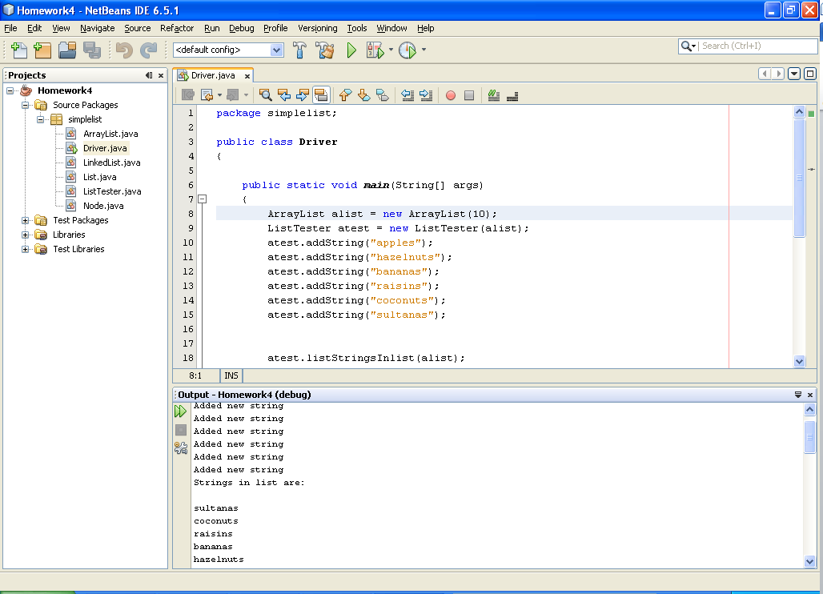
Output Window
Project
Source Code with 4 lines of comments
// COSC 1320 Semester (example: Spring 2015)
// Name: (example: John Doe)
// Document (example: Homework2.5)
// This is my own work; I will not post
Homework2.6

